Introduction:
Our comparison lies between Linux and Windows. The selection between Linux and Windows as an operating system represents a fundamental one in the age of digital evolution and forms the foundation of our digital existence. This decision affects more than just the software we choose to use. it is the fundamental factor influencing how we engage with technology. Of all the operating system choices available, Windows and Linux stand out as powerful mainstays. They each possess unique qualities that have a significant impact on our devices' functionalities, our security measures, the range of customization options available to us, and our overall computing experience.

This comparison of the contrast between these two titans of technology encourages a thorough examination of their subtle characteristics, unique user interfaces, wide range of software options, and flawless user interaction with the individual requirements and preferences of the user. A deeper exploration of this comparative journey reveals the underlying thread that connects the complex mix of digital interaction, functionality, and user experience in addition to the obvious differences on the surface. This analysis seeks to provide consumers with a clear understanding of the complex world of operating systems so they may make decisions that align both with their practical needs and their digital ambitions.

Objectives:
• Emphasize how important it is to choose an operating system in the digital world.
• Aim to gain more knowledge about the two main operating systems in use today.
• Examine and contrast Windows' and Linux's special features.
• Give customers a thorough understanding of operating systems so that they can match their goals and demands.
• This will support underlining the depth of learning, the user-centric approach, and the goal of enlightening consumers so they can choose an operating system with knowledge.

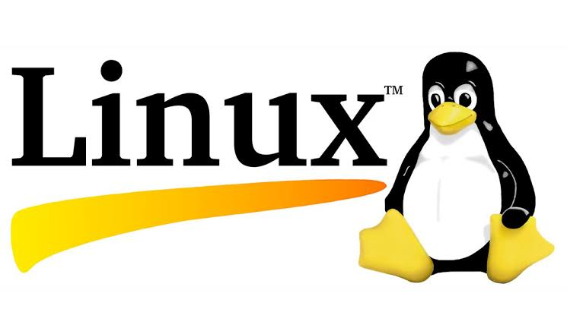
II. Second Operating System

Description:
- An operating system acts as a bridge between a device's physical hardware and software programs. Renowned for being an open-source operating system, Linux manages the important system resources like CPU, memory, and storage to guarantee smooth communication between hardware and software. It serves as an intermediary, establishing links between your different apps and the physical resources that carry out their operations. Because it's open-source, users can customize and work in a collaborative development environment, allowing them to customize their computing experiences to fit their unique requirements.
Linux was designed to be similar to UNIX, but has evolved to run on a wide variety of hardware from phones to supercomputers. Every Linux-based OS involves the Linux kernel which manages hardware resources and a set of software packages that make up the rest of the operating system. Organizations can also choose to run their Linux OS on a Linux server.
It was released under the GNU General Public License, Linux is a free and open-source operating system. Linux is also known to be the world’s largest open-source software project. Programmers and developers, both professional and amateur, from all over the world contribute to the Linux kernel by adding new features, identifying and resolving bugs and security problems, live patching, and offering fresh concepts all while giving back to the community.

History:
Linux starts with Linus Torvalds, who began work on the code in 1991 while a student at the University of Helsinki. Linus wanted to create a better alternative to MINIX, a UNIX-based operating system developed for use in the educational field. The problem with MINIX was that users could not modify or freely distribute the code. Using almost exclusively the C-programming language, Linus developed the Linux kernel using the foundation laid by Richard Stallman’s work on the GNU project. Work was completed on the project over the next few years, and Linus released version 1.0 of Linux in 1994. Not long after, Red Hat and Suse became the first Linux distributions based on the original kernel.
Linux exploded in popularity over the next few years. Within a decade, Linux was ported to thousands of different types of devices and received the support of major companies like Compaq, HP, and Dell. Additionally, Dell became the first manufacturer to offer Linux across its entire product line. Over the next two decades, dozens of new Linux distributions are released, driven mainly by hobbyist developers. Today, Ubuntu is the most popular distribution of Linux, with over 25 million users worldwide. Although Linux doesn’t enjoy the huge popularity that Microsoft Windows and Mac OS have, it still caters to a niche audience. Additionally, since Linux is completely open source, there are no licensing fees or costs to use it.

Developer:
Linus Torvalds is the developer of Linux. He began working on the code in 1991 while studying at the University of Helsinki. He wanted to create a free alternative to the MINIX operating system, which had limitations on code modification and distribution.

Architecture and design:
The architecture of Linux was created with configurability and modularity in mind. It is divided into layers and includes the kernel, system libraries, shell, system calls, programs, graphical user interface, and device drivers, among other necessary parts. Both consumers and developers can customize and have a great deal of freedom with this layered approach.

User interface:
Linux has a wide variety of user interfaces (UIs) available , which can be broadly classified into two categories which is the Graphical User Interface (GUI) and Command Line Interface (CLI). Users can interact with the system using the GUI, It offers a variety of alternatives such GNOME, KDE Plasma, XFCE, and more. For individuals who are used to graphical interactions, these GUIs offer a comfortable interface with windows, menus, buttons, and icons. On the other hand, text commands can be used to interact with the system via the CLI, which can be accessed through a terminal emulator. Those who want a more script-based, direct contact with the operating system can do so with this interface's strong control and flexibility. Linux users are free to select any of these interfaces according to their tastes, or to alternate between them in order to fit the duties at hand.

Software availability:
Linux is supported on almost every major computer platform, including x86, ARM and SPARC, making it one of the most widely supported operating systems.

Stability and Reliability:
Linux is known for its stability and reliability. It is widely used in servers and critical systems due to its ability to run for long periods without requiring a reboot. This makes it a popular choice for both personal and enterprise use.

Performance and resource:
Linux performance refers to how efficiently a Linux system utilizes its resources, such as CPU, memory, disk, and network, to execute tasks. It encompasses factors like speed, responsiveness, throughput, and resource utilization efficiency. Monitoring tools like top, htop, or tools provided by specific distributions help track and optimize these resources for better system performance.

Security:
Linux is a secure operating system and this is mainly because the system has numerous built-in features to keep it secure, including automatically assigning low user permissions. In addition, a large community keeps Linux secure by regularly testing its vulnerabilities and creating security patches.

Scheduling Algorithm:
The Linux scheduling algorithm works by dividing the CPU time into epochs . In a single epoch, every process has a specified time quantum whose duration is computed when the epoch begins. In general, different processes have different time quantum durations.

Memory Management:
Linux uses demand paging to load executable images into a processes virtual memory. Whenever a command is executed, the file containing it is opened and its contents are mapped into the processes virtual memory. This is done by modifying the data structures describing this processes memory map and is known as memory mapping.

Cost and Licensing:
Linux is an open-source operating system, using it is typically cost-free. Numerous distributions (such as Fedora, Debian, Ubuntu, etc.) and the core Linux kernel are free of charge. Linux's open-source nature, which permits users to view, alter, and share the source code, is one of its main benefits. Although the Linux operating system is free, there may be fees for enterprise-level support, certifications, or particular services and applications that are developed on top of Linux by outside companies. Furthermore, several businesses provide Linux distributions commercial support; this support may be paid for.

Linux is offered under various open-source licenses, such as the GNU General Public License (GPL), which allow users to freely use, alter, and distribute the program. The licensing terms of specific software packages and individual distributions should be reviewed, though, as they may vary.

